# Detailed information

## Read Me First

[Home](https://webcf.waybackmachine.org/web/20180710204948/http:/frame-online.eu/)  [FRAME ARCHITECTURE](https://webcf.waybackmachine.org/web/20180710204948/http:/frame-online.eu/frame-architecture)  [Detailed information](https://webcf.waybackmachine.org/web/20180710204948/http:/frame-online.eu/frame-architecture/detailed-information)  Read Me First

*feel free to contact us:*  info(at)frame-online.net

**The FRAME Architecture** (officially called the European ITS Framework Architecture) was developed as a result of recommendations from the High Level Group on transport telematics, which were supported by a resolution of the Council of Ministers. It was created and first published by the EC funded project KAREN in October 2000. The underlying aim of this initiative was to promote the deployment of (mainly road-based) ITS in Europe by producing… [read more](https://webcf.waybackmachine.org/web/20180710204948/http:/frame-online.eu/frame/what-is-the-frame-architecture)

**What kind of information do you want to find out about the FRAME Architecture?**

* [**Seminars and/or Training**](https://webcf.waybackmachine.org/web/20180710204948/http:/frame-online.eu/frame-forum/seminars-workshops)
* **Non-technical** – Please see [What is an ITS Architecture](https://webcf.waybackmachine.org/web/20180710204948/http:/frame-online.eu/frame/what-is-an-its-architecture) or [Why do you need an ITS Architecture](https://webcf.waybackmachine.org/web/20180710204948/http:/frame-online.eu/frame/why-you-need-an-its-architecture)
* [**The FRAME Architecture and the ITS Action Plan**](https://webcf.waybackmachine.org/web/20180710204948/http:/frame-online.eu/frame/detailed-information/relationship-with-the-its-action-plan-and-its-directive)
* **Technical** – What kind of technical information are you looking for?
  + **The FRAME Architecture itself** –
  + This is contained within two complementary tools, [The Browsing Tool](https://webcf.waybackmachine.org/web/20180710204948/http:/frame-online.eu/frame/the-browsing-tool) and [The Selection Tool](https://webcf.waybackmachine.org/web/20180710204948/http:/frame-online.eu/frame/the-selection-tool)
  + **Articles on topics related to the FRAME Architecture** – Please see [Detailed information](https://webcf.waybackmachine.org/web/20180710204948/http:/frame-online.eu/frame/detailed-information)
  + **An answer to a specific question** – Please see [FAQs](https://webcf.waybackmachine.org/web/20180710204948/http:/frame-online.eu/frame/faqs)
  + **In depth Information about the FRAME Architecture** – Please look in the [Library](https://webcf.waybackmachine.org/web/20180710204948/http:/frame-online.eu/library)

## The FRAME Architecture Version 4.1

[Home](https://webcf.waybackmachine.org/web/20180810234259/http:/frame-online.eu/)  [FRAME ARCHITECTURE](https://webcf.waybackmachine.org/web/20180810234259/http:/frame-online.eu/frame-architecture)  [Detailed information](https://webcf.waybackmachine.org/web/20180810234259/http:/frame-online.eu/frame-architecture/detailed-information)  The FRAME Architecture Version 4.1

*feel free to contact us:*  info(at)frame-online.net

The FRAME Architecture now contains the Cooperative Systems services and applications developed by the COOPERS, CVIS and SAFESPOT FP6 Integrated Projects.  This extension now brings the total number of principal Functional Areas supported by the FRAME Architecture to nine, as shown below. A document containing a brief summary of the contents of each Functional Area can be found in [download](https://webcf.waybackmachine.org/web/20180810234259/http:/frame-online.eu/wp-content/uploads/2015/04/The-FRAME-Architecture-Contents.pdf) (500kB pdf file).  
[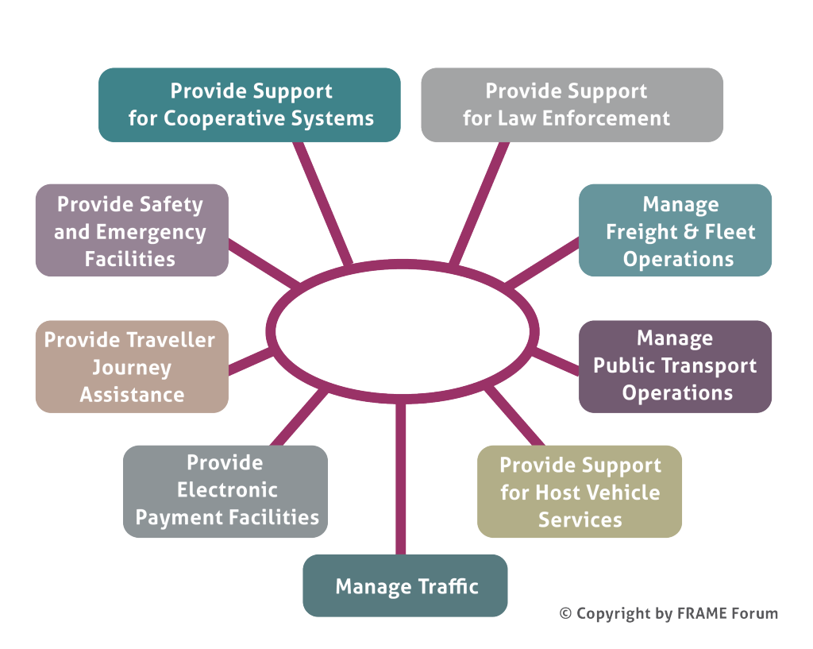](https://webcf.waybackmachine.org/web/20180810234259/http:/frame-online.eu/wp-content/uploads/2015/03/FRAME-Functional-Areas-N.png)

The new version can be found in [The Browsing Tool](https://webcf.waybackmachine.org/web/20180810234259/http:/frame-online.eu/frame/the-browsing-tool), and [The Selection Tool](https://webcf.waybackmachine.org/web/20180810234259/http:/frame-online.eu/frame/the-selection-tool) has a database that corresponds to it.

The presentation of the User Needs in the Browsing and Selection Tools can be difficult to read en masse, and a so a fully formatted set can be found in [download](https://webcf.waybackmachine.org/web/20180810234259/http:/frame-online.eu/wp-content/uploads/2014/10/FRAME-User-Needs-V4.1-01.pdf) (700kB pdf file) or [download](https://webcf.waybackmachine.org/web/20180810234259/http:/frame-online.eu/wp-content/uploads/2014/10/FRAME-User-Needs-V4.1-01.doc) (1.4MB doc file). A pictorial version of the structure of the User Needs can be found in [download](https://webcf.waybackmachine.org/web/20180810234259/http:/frame-online.eu/wp-content/uploads/2014/10/FRAME-User-Needs-Structure.pdf) (350kB pdf file).

Please send any comments to [info(at)frame-online.net](https://webcf.waybackmachine.org/web/20180810234259/mailto:info@frame-online.net).

Those who need to know the precise changes that have been made between V4.0 and V4.1 should also contact [info(at)frame-online.net](https://webcf.waybackmachine.org/web/20180810234259/mailto:info@frame-online.net).

## What is the FRAME Architecture

[Home](https://webcf.waybackmachine.org/web/20201230134437/https:/frame-online.eu/)  [FRAME ARCHITECTURE](https://webcf.waybackmachine.org/web/20201230134437/https:/frame-online.eu/frame-architecture)  What is the FRAME Architecture

**The FRAME Architecture** (originally called the European ITS Framework Architecture) was developed as a result of recommendations from the High Level Group on transport telematics, which were supported by a resolution of the Council of Ministers. It was created and first published by the EC funded project KAREN in October 2000. The underlying aim of this initiative was to promote the deployment of (mainly road-based) ITS in Europe by producing a framework which would provide a systematic basis for planning ITS implementations, facilitate their integration when multiple systems were to be deployed, and help to ensure inter-operability, including across European borders.

A distinctive feature of the FRAME Architecture is that it is designed to have sub-sets created from it, and is thus unlikely to be used in its entirety. Indeed, on occasions, it contains more than one way of performing a service and the user can select the most appropriate set of functionality to deliver it in that environment. Thus the FRAME Architecture is not so much a model of integrated ITS, as a framework from which specific models of integrated ITS can be created in a systematic and common manner.

The FRAME Architecture now covers the following areas of ITS:

* Electronic Fee Collection
* Emergency Notification and Response – Roadside and In-Vehicle Notification
* Traffic Management – Urban, Inter-Urban, Parking, Tunnels and Bridges, Maintenance and Simulation, together with the Management of Incidents, Road Vehicle Based Pollution and the Demand for Road Use
* Public Transport Management – Schedules, Fares, On-Demand Services, Fleet and Driver Management
* In-Vehicle Systems – includes some Cooperative Systems
* Traveller Assistance – Pre-Journey and On-Trip Planning, Travel Information
* Support for Law Enforcement
* Freight and Fleet Management
* Provide Support for Cooperative Systems – specific services not included elsewhere, e.g. bus lane use, freight vehicle parking
* Multi-modal interfaces – links to other modes when required, e.g. travel information, multi-modal crossing management

Because the FRAME Architecture is intended for use within the European Union it conforms to the precepts of subsidiarity, and thus does not mandate any physical or organisational structure on a Member State. It comprises only a set of User Needs which describe what ITS can provide, and a Functional View showing how it can be done. The Methodology, which is supported by computer-based tools, assists the creation of logically consistent sub-sets of the FRAME Architecture Functional View, and the creation of subsequent Physical Views.

## Planning Integrated ITS Deployments

[Home](https://webcf.waybackmachine.org/web/20201230134903/https:/frame-online.eu/)  [FRAME ARCHITECTURE](https://webcf.waybackmachine.org/web/20201230134903/https:/frame-online.eu/frame-architecture)  [Detailed information](https://webcf.waybackmachine.org/web/20201230134903/https:/frame-online.eu/frame-architecture/detailed-information)  Planning Integrated ITS Deployments

The FRAME Architecture is intended to be used to help the planning and deployment of integrated ITS for a region over a period of time (see diagram below). An ITS Architecture is created for that region to show what is required. Then, in each financial period, a set of applications or services can be chosen and the System Requirements Specification and the Test Specification parts of a Call for Tender can be written using the descriptions obtained from the relevant parts of the ITS Architecture.

[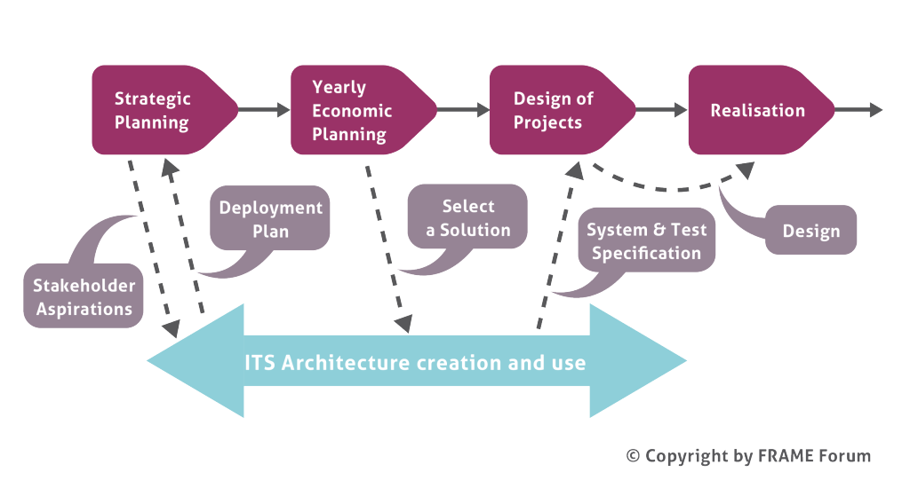](https://webcf.waybackmachine.org/web/20201230134903/https:/frame-online.eu/wp-content/uploads/2015/03/Rydmell-Deployment-Diagram-N.png)

**A second way**of considering the planning process is shown in the waterfall lifecycle below, which shows the tasks to be performed and who performs them. This shows that a typical ITS deployment can be a two stage process. In the first stage a local authority or road operator produces a Call for Tender. In the second stage the company that wins the contract develops and deploys the equipment. An ITS Architecture is created during the first stage and is used to provide many of the details of the Call for Tender.

[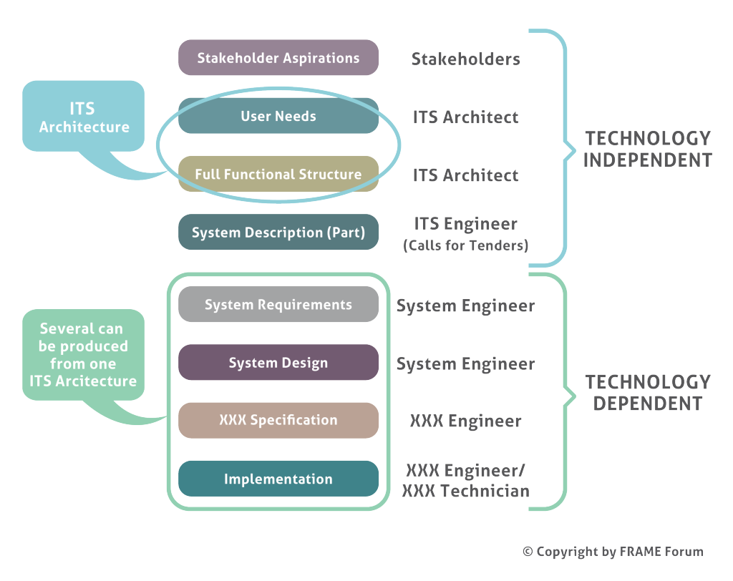](https://webcf.waybackmachine.org/web/20201230134903/https:/frame-online.eu/wp-content/uploads/2015/03/Waterfall-Lifecycle-N.png)Note – an ITS Architect is an ITS Engineer with a knowledge of ITS Architecture

**A third way** of considering the planning process is shown in the diagram below.

[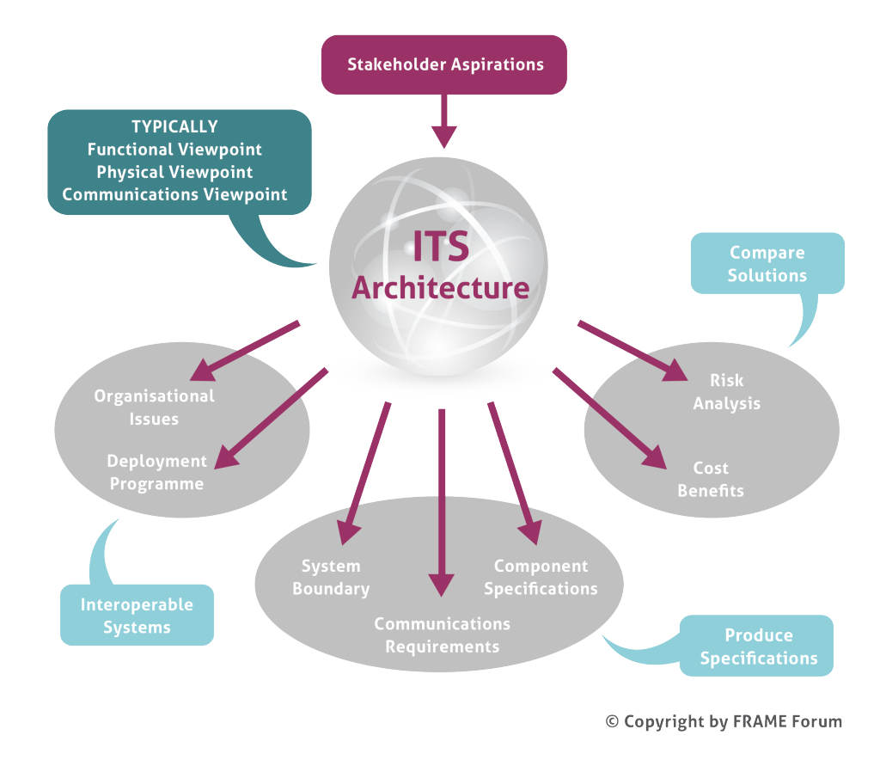](https://webcf.waybackmachine.org/web/20201230134903/https:/frame-online.eu/wp-content/uploads/2015/03/Cloud-and-Outputs-N.png)The process begins with the various stakeholder stating what they want from the ITS deployment in a set of **Stakeholder Aspirations**.

Once an ITS Architecture has been created various issues can be studied and products created as follows:

* **System Boundary**– Shows what is provided by the system and what is not[,](https://webcf.waybackmachine.org/web/20201230134903/http:/itslaboratories.com/) and the relationship between the System and the parts of its environment with which it interacts (see also [The FRAME Model](https://webcf.waybackmachine.org/web/20201230134903/https:/frame-online.eu/frame-architecture/detailed-information/the-frame-model))
* **Component Specifications and Communications Requirements**– for Calls for Tender
* **Deployment programme**– the plan for he deployment of equipment and communication. This includes what to do with existing systems and equipment
* **Organisational View**– who owns and/or manages and/or operates each part of the integrated system (see also [How can you use the Organisational View](https://webcf.waybackmachine.org/web/20201230134903/https:/frame-online.eu/frame-architecture/detailed-information/how-can-you-use-the-organisational-view))
* **Cost/Benefits Study**– the costs and the expected benefits of the ITS deployment (see also [How can you undertake a Cost/Benefit Analysis?](https://webcf.waybackmachine.org/web/20201230134903/https:/frame-online.eu/frame-architecture/detailed-information/how-can-you-undertake-a-costbenefit-analysis))
* **Risk Analysis**– deployment hazards[,](https://webcf.waybackmachine.org/web/20201230134903/http:/itslaboratories.com/) their risks and possible mitigations (see also [How can you undertake a Risk Analysis?](https://webcf.waybackmachine.org/web/20201230134903/https:/frame-online.eu/frame-architecture/detailed-information/how-can-you-undertake-a-risk-analysis))

**A fourth way** of considering the planning process is shown in the diagram below.

[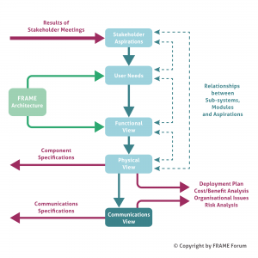](https://webcf.waybackmachine.org/web/20201230134903/https:/frame-online.eu/wp-content/uploads/2018/06/FRAME-Methodology.png)Once an ITS Architecture has been created from the FRAME Architecture the requirements of the communications links (physical data flows) can be compared with existing communications standards and technologies. If these already exist then they should be used, but if not then it may be necessary to initiate their development.

If necessary the ITS Architecture, and its communications requirements, can be analysed as described in the “third way” above, and changes made if found to be necessary.

The ITS Architecture, and its communications requirements, form the basis on which the Procurement Process takes place, which leads to the ITS implementation.

Further Reading

“[Many Languages, One Voice](https://webcf.waybackmachine.org/web/20201230134903/https:/frame-online.eu/wp-content/uploads/2014/10/Many-Languages-One-Voice-TH-Mar-Apr-2011.pdf)” from Thinking Highways Vol 6 No 1, Mar/Apr 2011

## Creating an ITS Architecture using FRAME

[Home](https://webcf.waybackmachine.org/web/20201230134903/https:/frame-online.eu/)  [FRAME ARCHITECTURE](https://webcf.waybackmachine.org/web/20201230134903/https:/frame-online.eu/frame-architecture)  [Detailed information](https://webcf.waybackmachine.org/web/20201230134903/https:/frame-online.eu/frame-architecture/detailed-information)  Creating an ITS Architecture using FRAME

The methodology for creating an ITS Architecture from the FRAME Architecture is illustrated in the figure below. The use of particular technologies or supplier products is not included in the FRAME Architecture. This is important for two reasons. Firstly the ITS Architectures created using the methodology will not become obsolete through advances in technology, or product development, and secondly it opens up the possibility for the development of new technologies to enable particular functionality to be provided.

[](https://webcf.waybackmachine.org/web/20201230134903/https:/frame-online.eu/wp-content/uploads/2018/06/FRAME-Methodology.png)**Stakeholder Aspirations**

Stakeholder Aspirations are statements that express the expectations and desires of the various stakeholders for the services that the ITS implementation will provide. They should be written by the stakeholders, but experience has shown that help is often needed from the architecture team. There are four classes of stakeholder, as follows:

* **Want ITS**– this class comprises organisations that need ITS services to enable their road networks to be used safely and efficiently. It also includes public transport operators and freight operators where ITS can enable them to improve the efficiency with which they move people and goods.
* **Use ITS**– this class comprises the end users who make use of the ITS services and/or operate the equipment. It includes travellers on a multi-modal journey as well as all classes of vehicle driver; freight shippers; pubic transport mangers and specialist system operators.
* **Rule ITS**– this class represents those who provide regulations and standards. It includes national governments and the various Standards making bodies.
* **Make ITS**– the class comprises the equipment and system manufacturers, communications providers and the system integrators.

Service providers, e.g. travel information and trip planning, may be in one or more of the Want, Use and Make ITS classes.

User Needs

It is normal to find that the Stakeholder Aspirations will have been written in a variety of styles. Sometimes they can also be obscure and inconsistent. It is thus necessary to re-write them in a consistent manner that is suitable for the next stage in the process. The result is a set of User Needs that express the Stakeholder Aspirations in a consistent and stylised manner whose meaning is clear and whose properties are testable.

The KAREN project produced a set of about 550 User Needs to cover the ITS applications and services being considered for implementation at the end of the 1990’s. The FRAME projects have then added to them with, most recently, the E-FRAME project adding about 230 User Needs for Cooperative Systems. Thus, when using the FRAME Architecture, the architecture team needs to write new User Needs only very occasionally. Most of the time the User Needs required can be selected from the existing list.

Functional View

*The FRAME methodology uses the term “Views” for the parts that make up the FRAME Architecture and its resultant ITS Architectures. This follows the recommendations of IEEE 1471. The alternative term of “Architecture” is still used elsewhere, but we feel that an architecture made up of views is more comprehensible than one that is made up of architectures.*

A Functional View (sometimes called a Logical View) shows the functionality that will be required to fulfil the User Needs, and hence the Stakeholder Aspirations. When using the FRAME Architecture the Functional View is shown as Data Flow Diagrams that contain functions, data stores and terminators, and the data that flows between them. Each of these is provided with its own description which, in the case of functions, includes statements explaining what they do. Since the FRAME Architecture comprises a Functional View that satisfies all of its User Needs, the architecture team only has to select those parts of it that serve the User Needs that have been mapped to the Stakeholder Aspirations. New functions etc. are only needed for Stakeholder Aspirations that have required new User Needs to be added.

Another important part of the Functional View is the Context Diagram. This shows the ITS as a single item and the links needed by the functionality contained within it to communicate with the entities outside it. It is useful for two reasons. Firstly it enables the system boundary to be defined showing what is inside the ITS and what is not, and thus what is the responsibility of the ITS Engineers (and hence what its not!). Secondly it enables definitions to be produced of the way in which the functionality inside the ITS expects the outside entities to behave. These outside entities are called Terminators, and either obtain data for the ITS or provide outputs to end users. The same Context Diagram is also part of the Physical View.

Physical View

Once the Functional View is complete, the architecture team allocates each item of functionality to a location, either within a sub-system (see diagram below), or within a module that is part of a sub-system. Once this has been completed the component (sub-system or module) specifications can be created from the definitions of the functions and data stores contained within them.

[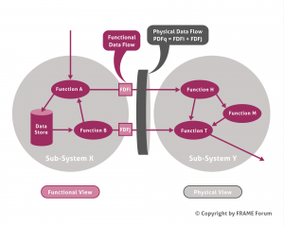](https://webcf.waybackmachine.org/web/20201230134903/https:/frame-online.eu/wp-content/uploads/2018/06/FRAME-Physical-View.png)The Context Diagram produced as part of the Functional View also applies to the Physical View. It again shows the ITS as a single item and the links needed by the functionality within it to communicate with the entities outside it.

Communications View

As can be seen from the diagram above, a consequence of allocating the functionality to sub-systems (and modules), is that it is immediately clear which Functional Data Flows lie within a sub-system (or module), and which pass between one sub-system and another, or between one module and another. Those that pass between sub-systems or modules make up the Physical Data Flows, and represent a communication channel between sub-systems, and/or between modules.

Since sub-systems are, by definition, located in different places (e.g. in a traffic management centre, at the road side, in a vehicle) it is possible to produce communications specifications by analysing the contents of each Physical Data Flow. This analysis may elicit that an existing Standard may be used for the communications. Alternatively it can be used as the basis for defining a new Standard if the need for one can be agreed.

Analysis of the Physical Data Flows that pass between the ITS and the Terminators can also lead to “standard” interfaces for end users, which can play an important part in making sure that the ITS implementation can be used in the same way, everywhere that it is deployed.

Traceability

An important feature of the FRAME Architecture methodology is the ability to provide traceability all the way through the process. It should be noted that the services contained in most ITS Architectures cannot normally be deployed all at the same time, both for reasons of cost, as well for reasons of dependability (i.e. one service may have to be established before another can be introduced). Thus those planning to implement components and communications links identified by the ITS Architecture need to take account of any financial and dependability constraints that the proposed deployment may have.

A traceability matrix can be used to show the relationship between the Stakeholder Aspirations and the sub-systems and modules in the Physical View. This enables the ITS Architecture owners to identify quickly those components that are needed to satisfy a given set of Aspirations, and thus meet their immediate goals. Such a matrix can also show whether certain Aspirations can be satisfied “for free”, i.e. having identified the sub-systems and/or modules needed to satisfy a given set of Aspirations, it may be found that it is possible to satisfy some other Aspirations without the need for extra sub-systems and/or modules.

Further Reading

* [Things to Make and Do](https://webcf.waybackmachine.org/web/20201230134903/https:/frame-online.eu/wp-content/uploads/2014/10/Things-to-Make-and-Do-TH-Nov-Dec-2010.pdf) from Thinking Highways Vol 5 No 4, Nov/Dec 2010
* [A Particularly Common Goal](https://webcf.waybackmachine.org/web/20201230134903/https:/frame-online.eu/wp-content/uploads/2014/10/A-Particularly-Common-Goal-TH-Nov-Dec-2010.pdf) from Thinking Highways Vol 5 No 4, Nov/Dec 2010
* [Using the European ITS Framework Architecture](https://webcf.waybackmachine.org/web/20201230134903/https:/frame-online.eu/wp-content/uploads/2014/10/its-wc-2006.pdf) (ITS World Congress 2006)

## Relationship with the ITS Action Plan and ITS Directive

[Home](https://webcf.waybackmachine.org/web/20180801174229/http:/frame-online.eu/)  [FRAME ARCHITECTURE](https://webcf.waybackmachine.org/web/20180801174229/http:/frame-online.eu/frame-architecture)  [Detailed information](https://webcf.waybackmachine.org/web/20180801174229/http:/frame-online.eu/frame-architecture/detailed-information)  Relationship with the ITS Action Plan and ITS Directive

*feel free to contact us:*  info(at)frame-online.net

Action Area 2.3 of the EU ITS Action Plan requires the use of ITS Architectures to support the European objectives of the Plan.  This booklet explains how the European ITS Framework Architecture, also known as the FRAME Architecture, provides a suitable basis for this task.  The principal reasons are:

* The FRAME Architecture covers almost all of ITS. Most of the applications and services mentioned in the ITS Action Plan are contained within the FRAME Architecture.
* The FRAME Architecture does not impose any technical or organisational assumptions on the way things are done – it is thus suitable for use within the ITS Action Plan
* The FRAME Architecture enables a system structure to be described in a technology independent way so that, as technology evolves, all the higher level requirements can remain unchanged.
* The FRAME Architecture was first published in 2000 and has been used to create ITS Architecture subsets for Member States, their regions, as well as for RTD projects.

**What is an ITS Architecture?**

* A high-level design that defines the structure, behaviour and integration of a given system in its surrounding context.
* A description which forms the basis for a class of systems and hence for a set of low-level designs.
  + Different low-level designs can be created by different manufacturers;
  + Adherence to the ITS Architecture ensures inter-operability.
* It ensures an open-market for services and equipment, because there are “standard” interfaces between components.
* It ensures consistency of information delivered to end users

**About the FRAME Architecture**

Following the recommendation of the High Level Group on Telematics, and a resolution of the Transport Council, the European ITS Framework Architecture, colloquially known as “The FRAME Architecture”, was produced by the EC funded project KAREN (1998-2000).  It has been maintained and enhanced continuously since then – with cooperative systems being added by the current project E-FRAME (2008-11).  Clearly this architecture is a candidate for use by those who are implementing the ITS Action Plan.

Because the FRAME Architecture is intended for use within the European Union it conforms to the precepts of subsidiarity, and thus does not mandate any physical or organisational structures on its users.  Hence the FRAME Architecture makes no assumptions about the way that things are done.

The FRAME Architecture was created to provide a common approach, or “language”, for use throughout the EU so that the implementation of integrated and inter-operable ITS can be planned.

It is a framework architecture from which logically consistent sub-sets can be created, which can then be used on their own.  The methodology is supported by computer-based tools, and begins with the wishes, or aspirations, of the various stakeholders for ITS applications and services.  These are identified within the FRAME Architecture and a sub-set is selected.  The sub-set is then customised to fit the region in which they are to be deployed.  See below for further explanations.

[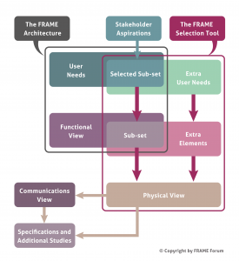](https://webcf.waybackmachine.org/web/20180801174229/http:/frame-online.eu/wp-content/uploads/2018/06/FRAME-Architecture-Diagram.png)

***The process of creating an ITS Architecture Sub-set***

**Scope of the FRAME Architecture**

The FRAME Architecture now covers the following areas of ITS:

* Electronic Fee Collection;
* Emergency Notification and Response – Roadside and In-Vehicle Notification;
* Traffic Management – Urban, Inter-Urban, Simulation, Parking, Tunnels and Bridges, Maintenance, together with the Management of Incidents, Road Vehicle Based Pollution and the Demand for Road Use;
* Public Transport Management – Schedules, Fares, On-Demand Services, Fleet and Driver Management;
* In-Vehicle Systems – includes Cooperative Systems;
* Traveller Assistance – Pre-Journey and On-Trip Planning, Travel Information;
* Support for Law Enforcement;
* Freight and Fleet Management;
* Provide Support for Cooperative Systems – specific services not included elsewhere such as bus lane use, freight vehicle parking.
* Multi-modal interfaces – links to other modes when required, e.g. travel information, multi-modal crossing management

**FRAME Forum**

The FRAME Forum was set up in 2005 to promote the use of the FRAME Architecture, and to govern its maintenance and evolution.  It is currently being restructured and reorganised for the new scenario created by the ITS Action Plan and ITS Directive, and to enable more users of the FRAME Architecture to be involved. New members are welcome to contribute to this task!

**Using the FRAME Architecture**

The FRAME Architecture is intended to be used within a top down approach to the planning and deployment of integrated ITS.  The overall concept may, or may not, be represented in a formal (reference) model.  Since the creation of a reference model requires a number of decisions or choices to have been taken by those implementing and/or regulating ITS, the FRAME Architecture does not provide one.

The overall concept and the system structure should be described in a technology independent way so that, as technology evolves, all the higher level requirements remain unchanged.  The information contained within the system structure enables the ITS industry to produce the equipment and systems that will provide the services wanted by the stakeholders, each with their own distinctive features, but conforming to the purposes expressed in the overall concept and system structure.  Thus integrated and/or inter-operable ITS services can be provided across the EU.

[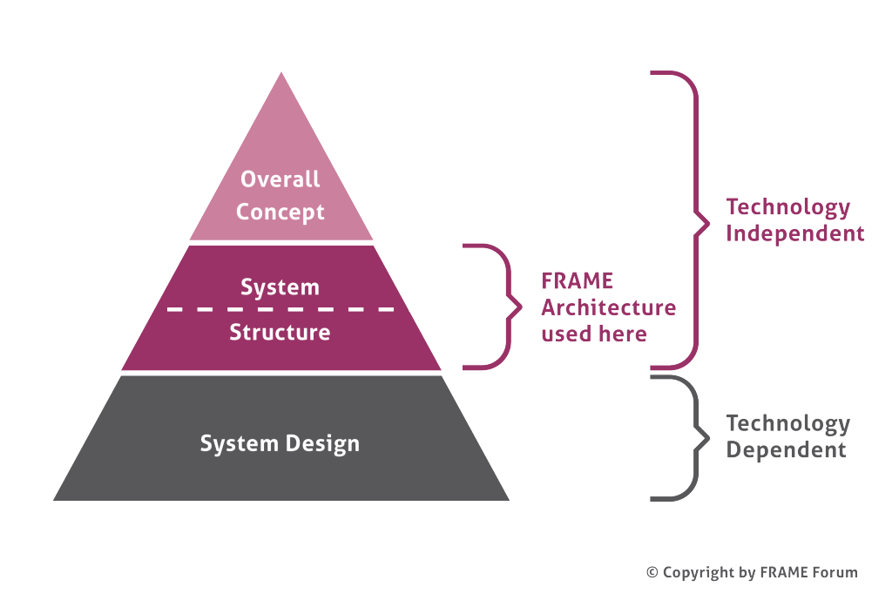](https://webcf.waybackmachine.org/web/20180801174229/http:/frame-online.eu/wp-content/uploads/2015/03/Architecture-Layers-n.png)***The use of the FRAME Architecture in the planning process***

The system structure contains a number of views.  The functionality needed to implement ITS Services is provided by the **Functional View**; which does not impose any specific technical solutions on its users.  Each specific implementation requires choices to be made by the stakeholders, in particular which components will be used for the ITS implementation and the links between them (the **Physical View**).

[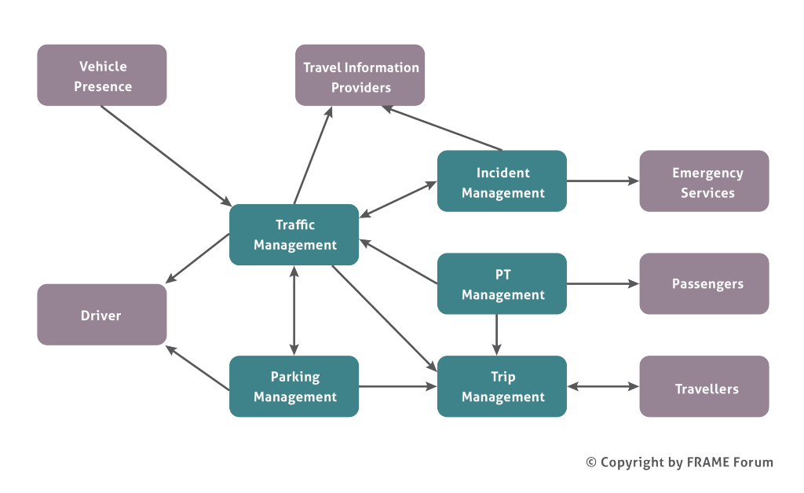](https://webcf.waybackmachine.org/web/20180801174229/http:/frame-online.eu/wp-content/uploads/2015/03/Example-Physical-Viewpoint-n.png)***Components of an ITS implementation – The Physical View***

Further analysis, also based on specific choices or decisions, can then provide:

* **Communications View**– the requirements for communications between the components.
* **Organisational View**– who owns, manages and operates each components and other organisational issues;
* **Information View**– information that is used, its attributes and relationships;

The content of the **Physical View** and the **Communications View** can be included in Calls for Tender to enable the components and communications to be procured and deployed.  The **Organisational View** is used to enable the correct management structure, plus rules and regulations, to be put in place so that the services can be correctly provided.

**FRAME AND THE ITS ACTION PLAN**

Although a number of other ITS Architectures do exist, most of them include certain technical or organisational assumptions and none has been used as extensively around the EU as the FRAME Architecture.  It is a mature and proven product with an ever increasing number of users, and hence an increasing knowledge base.  It can therefore be used immediately to support the ITS Action Plan.

* Most applications and services mentioned in the ITS Action Plan are also mentioned in the FRAME Architecture.
* New ideas are a feature of ITS, and the FRAME Architecture methodology enables them to be included immediately in a sub-set ITS Architecture.  It has thus been used successfully in RTD projects such as COOPERS.  When such new ideas become established they can be included in a later version of the FRAME Architecture, as has already been done for Cooperative Systems by the E-FRAME project.

**Multimodality**

The FRAME Architecture includes functionality to support data exchanges with other modes.

**System Design – Technologies**

In many places the ITS Action Plan refers to specific technologies, e.g. the EGNOS/Galileo positioning system, RFID and open in-vehicle platform architecture.  Such technology dependent issues should not be visible within an ITS Architecture, but the functionality they provide should be, and most – if not all – is already within the FRAME Architecture.  The ITS Architecture defines the various interfaces that exist between components, and the use of specific technology at those interfaces needs to be covered by standards, whose use may be mandated through the ITS Directive.

[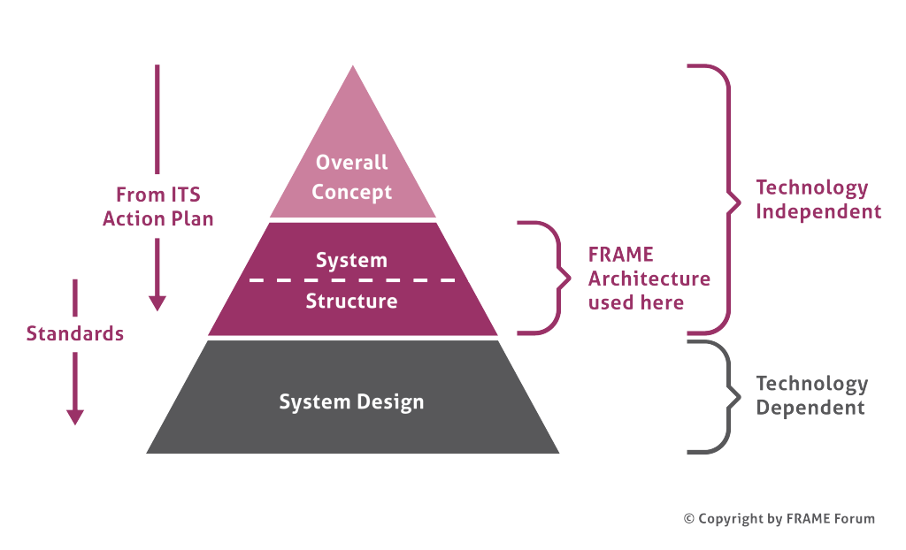](https://webcf.waybackmachine.org/web/20180801174229/http:/frame-online.eu/wp-content/uploads/2015/03/Architecture-Layers-Stds-n.png)***Architecture Layers and the EU ITS Action Plan***

**Supporting the ITS Action Plan**

Once the European Specification for each ITS application and service has been agreed, an ITS architecture for it can be created using a sub-set of the FRAME Architecture.  This will enable the required standards to be identified and, if necessary, their creation initiated.  It will also provide a technology independent description of each application and service so that manufacturers and suppliers can ensure their products will work together as required.  This creation of each European Specification should be done by a team of experts in the topic under consideration, with the addition of a small ITS Architecture team who will also ensure a common “look and feel” to the result.

This process will inevitably result in the creation of Physical, and possibly other, Views for use throughout the EU.  These can then be used directly by, for example, application developers allowing them to respond to a quickly changing market but preserving the links to the overall structure.  Thus, over time, the need for separate bespoke ITS Architectures within Member States, or parts of Member States, may diminish.

**Advantages of this Approach**

* **Common Language**– Each resulting ITS Architecture will be based on the FRAME Architecture, and thus use the same terminology.
* **Common elements** will be easy to identify, as will be the merging of two or more ITS Architectures.  Thus will be important as Member States with their own ITS Architectures need to include those that result from the ITS Action Plan or ITS Directive.
* **Efficient** – The FRAME Architecture already exists and contains about 80% of the work that will be needed to be done to create the ITS Architectures.

A copy of this article

This article is also available in the booklet [The FRAME Architecture and the ITS Action Plan](https://webcf.waybackmachine.org/web/20180801174229/http:/frame-online.eu/wp-content/uploads/2014/10/FRAME-ITS-Action-Plan.pdf) (3 MB pdf file)

Further Reading

[A Particularly Common Goal](https://webcf.waybackmachine.org/web/20180801174229/http:/frame-online.eu/wp-content/uploads/2014/10/A-Particularly-Common-Goal-TH-Nov-Dec-2010.pdf) from Thinking Highways Vol 5 No 4, Nov/Dec 2010 (4 MB pdf file)

## Relationship with other Cooperative Systems Activities

[Home](https://webcf.waybackmachine.org/web/20201230134904/https:/frame-online.eu/)  [FRAME ARCHITECTURE](https://webcf.waybackmachine.org/web/20201230134904/https:/frame-online.eu/frame-architecture)  [Detailed information](https://webcf.waybackmachine.org/web/20201230134904/https:/frame-online.eu/frame-architecture/detailed-information)  Relationship with other Cooperative Systems Activities

During FP6 a number of projects, in particular [SAFESPOT](https://webcf.waybackmachine.org/web/20201230134904/http:/www.safespot-eu.org/), [CVIS](https://webcf.waybackmachine.org/web/20201230134904/http:/www.cvisproject.org/) and [COOPERS](https://webcf.waybackmachine.org/web/20201230134904/http:/www.coopers-ip.eu/), and co-funded by the EC, developed a number of “proof of concept” Cooperative Systems. These have been analysed by the E-FRAME project, and a corresponding set of about 230 FRAME User Needs have been written, and for which the corresponding additional functionality has been added to the FRAME Architecture.

Meanwhile aspects associated with the communications needed for Cooperative Systems has been studied by the [COMeSafety](https://webcf.waybackmachine.org/web/20201230134904/http:/www.comesafety.org/) and [PRE-DRIVE C2X](https://webcf.waybackmachine.org/web/20201230134904/http:/www.pre-drive-c2x.eu/) projects. Many of the results of this work are being developed into Standards by either CEN or ETSI in accordance with [Mandate 453](https://webcf.waybackmachine.org/web/20201230134904/http:/ec.europa.eu/enterprise/sectors/ict/files/standardisation_mandate_en.pdf).

The following diagram show how the results of these two processes can be used.

[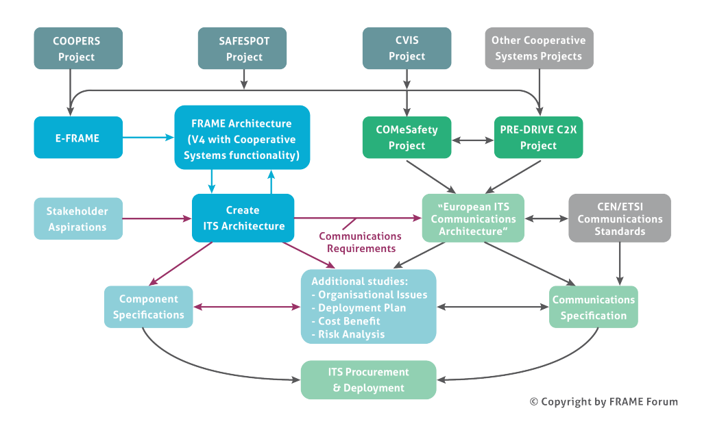](https://webcf.waybackmachine.org/web/20201230134904/https:/frame-online.eu/wp-content/uploads/2015/03/E-FRAME-Coop-Sys-Projects-V2-n.png)

The box “Create ITS Architecture” represents the process described in [Creating an ITS Architecture using FRAME](https://webcf.waybackmachine.org/web/20201230134904/https:/frame-online.eu/frame/detailed-information/creating-an-its-architecture-using-frame), and once a Physical View has been created for the local situation, the corresponding Communications Requirements can be identified. It is at this point that the work of the COMeSafety and PRE-DRIVE-C2X projects, and/or the corresponding Standards produced by CEN and ETSI as a result on Mandate 453, can be consulted to define the communications links fully.

## Why is FRAME a Framework Architecture?

[Home](https://webcf.waybackmachine.org/web/20201230134905/https:/frame-online.eu/)  [FRAME ARCHITECTURE](https://webcf.waybackmachine.org/web/20201230134905/https:/frame-online.eu/frame-architecture)  [Detailed information](https://webcf.waybackmachine.org/web/20201230134905/https:/frame-online.eu/frame-architecture/detailed-information)  Why is FRAME a Framework Architecture?

A principal objective for the FRAME Architecture is to promote the deployment of ITS in Europe by producing a framework which would provide a systematic basis for planning ITS implementations, facilitate their integration when multiple systems were to be deployed, and help to ensure inter-operability, including across European borders.

The FRAME Architecture achieves this objective by providing a model of almost all of ITS from which specific sub-sets of integrated ITS can be created in a systematic and common manner. It covers most ITS applications and services that are currently being used, or being considered for implementation, in Europe, and it does not impose any technical or organisational assumptions on the way things are done.

It therefore provides ITS engineers with a common approach, or “language”, for use throughout the EU.

Because the FRAME Architecture is intended for use within the European Union it conforms to the precepts of subsidiarity, and thus does not mandate any physical view or organisational structure on a Member State. It therefore consists of only a set of User Needs for ITS, and a Functional View that satisfies them; the remainder of the views are created when required. Thus the FRAME Architecture is “neutral” and makes no assumptions about the way things are done.

The way in which sub-sets can be created from the FRAME Architecture is described in [Creating an ITS Architecture using FRAME](https://webcf.waybackmachine.org/web/20201230134905/https:/frame-online.eu/frame/detailed-information/creating-an-its-architecture-using-frame).

## The FRAME model

[Home](https://webcf.waybackmachine.org/web/20201230134905/https:/frame-online.eu/)  [FRAME ARCHITECTURE](https://webcf.waybackmachine.org/web/20201230134905/https:/frame-online.eu/frame-architecture)  [Detailed information](https://webcf.waybackmachine.org/web/20201230134905/https:/frame-online.eu/frame-architecture/detailed-information)  The FRAME model

The FRAME model used for the Functional View is based on hierarchical [Data Flow Diagrams](https://webcf.waybackmachine.org/web/20201230134905/http:/en.wikipedia.org/wiki/Data_flow_diagram). At the highest level is the Context Diagram (see figure below) which shows all the functionality supported by the FRAME Architecture inside a box labelled “System” surrounded by a set of “Terminators”, which are outside the boundary of the system. Each Terminator represents some thing, or person, to which the system will send data and/or from which it will receive data. As there is a large amount of functionality in the FRAME Architecture (2-3000 elements in total), its size is managed using hierarchies of functions and terminators.

[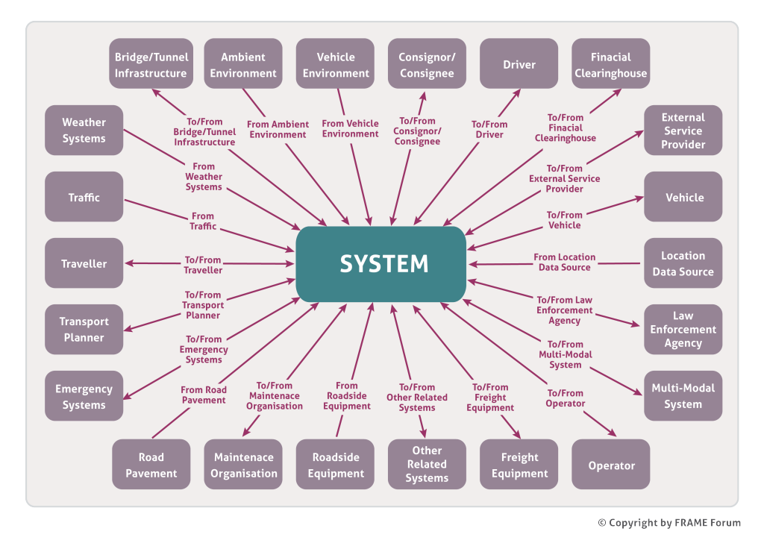](https://webcf.waybackmachine.org/web/20201230134905/https:/frame-online.eu/wp-content/uploads/2015/03/FRAME-Context-Diagram-n.png)***The FRAME Context Diagram***

The FRAME System in the figure above is divided into 9 Areas (see below). Each Area then has a number of hierarchical levels of functions as required, with each High-Level Function being decomposed into a number of lower-level Functions until the final Low-Level Functions are reached. Initially it was thought that the High-Level Functions would be used during the sub-set creation process, but it was quickly found that, whilst many of the corresponding Low-Level Functions were required in a given situation, not all them were. That, and the difficulty of following data flows through the hierarchy of functions, has resulted in the High-Level Functions being used solely for convenience when creating or looking at the entire FRAME Architecture. Thus the FRAME Architecture Functional View is now defined with its Low-Level Functions, and the creation of sub-sets is performed using only them.

The name “Terminator” derives from the fact that the data for, and produced by, the System starts/stops there. The FRAME Architecture sub-divides some of its Terminators into a number of Actors. Not only does this make the total architecture more manageable, especially the construction of the diagrams, but it is also useful for situations when some data goes to/from all Actors in the Terminator, e.g. all Drivers, and on other occasions data goes to/from a specific Actor, e.g. Public Transport Driver.

The 9 Areas of the FRAME Architecture

The FRAME Architecture models road based ITS applications and services, and is divided into the following nine broad Areas:

* Provide Electronic Payment Facilities
* Provide Safety and Emergency Facilities – includes both in-vehicle and roadside “eCall” plus the management of the Emergency Services responses
* Manage Traffic – includes urban and inter-urban traffic management, plus parking, incident and demand management
* Manage Public Transport Operations – includes both regular and on-demand services, plus fare cards and vehicle sharing
* Provide Advanced Driving Assistance Systems – includes support for in-vehicle services some of which are part of cooperative systems
* Provide Traveller Journey Assistance – includes both pre- and on-trip planning, plus traveller information
* Provide Support for Law Enforcement
* Manage Freight and Fleet Operations
* Provide Support for Cooperative Systems – includes support for cooperative systems not included elsewhere

Links to other modes of transport are made through the Terminator “Multi-Modal System”, which is used to provide travellers with multi-modal travel information, to manage multi-modal crossings and incidents that take place on other modes.

Multiple Copies of Items

Although the FRAME Architecture has only one copy of each element, it clearly has to be able to model situations when more than one identical physical unit is required. There are two ways that this is done:

* It is common practice, when high-level diagrams are drawn, to use a single “box” to represent lots of the same “boxes”, e.g. road side units. Thus a “box” in a Physical View may represent any number of copies of itself.
* Consider the situation when a Traffic Control/Management Centre needs to be able to pass data to/from another adjacent Traffic Control/Management Centre. In this situation it is necessary to be able to show that flow of data. This is done by using the terminator “Other Related System”, which represents a link to other instances of systems that have been produced using the FRAME Architecture

The User Needs

As an initial approximation the FRAME User Needs perform the task of system requirements for the Functional View, though in practice many of them were created in their final form after the Functional View had been produced. They perform three related tasks:

* They are a set of statements that, together, describe the tasks performed by the Function View. Each one uses the style “The system shall…” and so indicates the different functionality that needs to be performed by the ITS.
* Each Low-Level Function is cross-referenced to one or more User Needs and this provides a mechanism to make an initial selection of Functions for a particular sub-set of the FRAME Architecture. It should be noted that there is not an exact, or one-to-one, correlation between the User Needs and the Functions, and most are only cross-referenced to the primary functions that are required to support them. Only rarely will (some of) the secondary functions supplying data to the primary functions also be mentioned, since there can be many of them, often with their own suppliers of data.
* A few of the User Needs do not relate to the Functional View, but to other views or to non-functional requirements.

Logically each High-Level Function should have the User Needs of its constituent lower-level functions. However, when this was done, some High-Level Functions had so many User Needs that the benefit of the information was uncertain, indeed it normally caused confusion. Thus at the same time as it was decided to define the FRAME Architecture with its Low-Level Functions (see above), the associated User Needs were also removed from the High-Level Functions.

Extra Elements

On occasions it is possible that the user of the FRAME Architecture has to add elements to the Functional View for the following two main reasons:

* Since the FRAME Architecture does not claim to contain every ITS application or service, either because it has only recently been devised or its use is very specialised in one location, extra functionality may need to be added to support the missing item.
* On occasions the deployment of a particular service may require part of the functionality of a Low-Level Function to be in one location (in the Physical View), and the remainder in another. In this situation it will be necessary to create two additional Lower-Level Functions, and their associated data flows and data stores, which together perform the original Low-Level Function.

The FRAME Architecture is designed to enable users to do this for themselves and a description of how to do it is available in the [Selection Tool Reference Manual](https://webcf.waybackmachine.org/web/20201230134905/https:/frame-online.eu/wp-content/uploads/2014/10/selection-tool-reference-manual.pdf).

Configuration Management

The FRAME Architecture is maintained according to a strict set of [Configuration Management Rules](https://webcf.waybackmachine.org/web/20201230134905/https:/frame-online.eu/wp-content/uploads/2014/10/eitsfa-configuration-management.zip) (260kB pdf file), the objectives of which are to ensure that no ITS Architecture sub-set created from an earlier version will be invalidated by a later version. The primary consequences of this are that if the description of an element needs to be changed then it is given a new identifier, and that the identifier of an “obsolete” element is never re-used.

## The FRAME Architecture Views

[Home](https://webcf.waybackmachine.org/web/20201230134907/https:/frame-online.eu/)  [FRAME ARCHITECTURE](https://webcf.waybackmachine.org/web/20201230134907/https:/frame-online.eu/frame-architecture)  [Detailed information](https://webcf.waybackmachine.org/web/20201230134907/https:/frame-online.eu/frame-architecture/detailed-information)  The FRAME Architecture Views

Integrated ITS services are complex, and it is not possible to describe them completely in a single model or diagram. Instead we use a number of different models, each one concentrating on a different aspect of the integrated ITS services. As an example consider how people might describe a car. Some are interested in their colour and style, others are interested in the interior design. Technical issues, e.g. maximum speed, fuel consumption is another area to be considered as, of course, is the price. None of these attributes is sufficient to describe a car on its own, but together they built up a total picture i.e. they are each different views, or viewpoints, of a car (see below).

[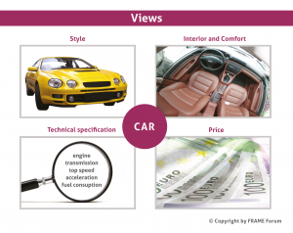](https://webcf.waybackmachine.org/web/20201230134907/https:/frame-online.eu/wp-content/uploads/2018/06/Different-Views.png)  
In a similar way we use a number of different views to describe a set of integrated ITS services which, together, form the ITS Architecture. The FRAME methodology use of the term “Views” follows the recommendations of IEEE 1471. The alternative term of “Architecture” is still used elsewhere, but we feel that an architecture made up of views is more comprehensible than one that is made up of architectures.

Whilst there are a very large number of possible Views, there are four principle views that are used by most users of the FRAME Architecture – The Functional, Physical, Communications and Organisational Views.

The Functional View

The Functional View (sometimes called the Logical View) describes the functionality (what is to be done) to create the various ITS services. The FRAME Architecture uses Data Flow Diagrams to define the Physical View, as these not only have the properties needed for the FRAME Architecture, i.e. the ability to be partitioned into consistent sub-sets, but they have been proven to be fully comprehensible by all those who need to understand them, in particular those with a non-technical background. A typical data flow diagram is made up of Functions, that “do” things, Data Stores that store sets of data for a length of time (but are not necessarily full databases), and Functional Data Flows that pass data between then, as shown in the example below.

[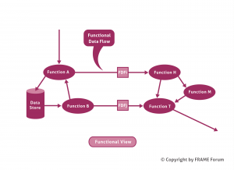](https://webcf.waybackmachine.org/web/20201230134907/https:/frame-online.eu/wp-content/uploads/2018/06/FRAME-Functional-View.png)

Physical View

A Physical View shows where, physically, each Function and Data Store is to be located. Example locations can be:

* Central – the place that is used by parts of a system to collect and manage the storage and processing of traffic data, toll payments, freight shipping orders, and/or the generation of traffic management measures, or fleet management instructions, with or without human intervention, e.g. a traffic control/information centre, or a freight and fleet management centre.
* Roadside – the place that is used by parts of a system for the detection of traffic, vehicles and pedestrians, or the collection of tolls, and/or the generation of traffic management measures, and/or the provision of information and commands to drivers and/or pedestrians.
* Vehicle – a device that is capable of moving through the road network and carrying one or more people (bicycles, motorcycles, cars, public transport vehicles) and/or goods (vans and any other form of vehicle able to carry freight on roads) in which parts of system can be installed during manufacture or can be added on later.
* Personal device – a nomadic device in which part of the system can be installed so that it can be easily used (and possibly carried) by travellers as one of their personal possessions.
* Freight device – a device in which part of the system can be installed so that it is an integral part of a freight carrying unit, e. g. freight container, trailer, or vehicle body.
* Kiosk – a device, usually located in a public place, into which part of the system can be installed to enable travellers to have limited and controlled access to some of its facilities.

But other names can be used, e.g. the name of a building instead of “Central”, in order to make things clear to the reader.

The example below shows the above Functions and Data Stores allocated either to Sub-System X or to Sub-System Y. A consequence on this is that the two Functional Data Flows FDFi and FDFj now have to pass between the two Sub-Systems and thus comprise a single Physical Data Flow.

[](https://webcf.waybackmachine.org/web/20201230134907/https:/frame-online.eu/wp-content/uploads/2018/06/FRAME-Physical-View.png)Sometimes it is useful to sub-divide a sub-system into two or more Modules, each containing a set of Functions and Data Stores to perform a specific task or service.

Communications View

A Communications View is the result of an analysis of the Physical Data Flows and describes the kinds of communications links that will be required. Of particular interest is:

* Size – the quantity of data in each item
* Time between the creation of the data and its use
* Time before a new value is required
* When one of the sub-systems is mobile

The first two items will provide the minimum data transfer rate. The third will indicate whether a data link can be shared, and the fourth will indicate whether a wireless link must be used.

The use of, or the need for, a communication standard can also be inferred from these results.

Organisational View

The above three views consider technical aspects of an ITS deployment, the organisational views considers the ownership and business issues, e.g. who owns what, who manages what, and the business/contractual relationships between the various parties involved.

The Organisation View is usually a derivative of the Physical View. It is used to show the organisations that will own, and/or operate, and/or maintain the Sub-Systems and Modules in the Physical View (see Section 6.4 in [Deployment and Organisational Issues for Cooperative Systems](https://webcf.waybackmachine.org/web/20201230134907/https:/frame-online.eu/wp-content/uploads/2014/10/D10-Deployment-and-Organisational-Issues-v1.0a.pdf)).

On occasions it is necessary for an ITS architecture to fit into a given organisational/legal/constitutional structure. On these occasions the Physical View must be created to meet these constraints. (see also [The FRAME Architecture and the ITS Action Plan](https://webcf.waybackmachine.org/web/20201230134907/https:/frame-online.eu/frame/detailed-information/relationship-with-the-its-action-plan-and-its-directive))

## Where are the FRAME Physical and Organisational Views?

[Home](https://webcf.waybackmachine.org/web/20201230134907/https:/frame-online.eu/)  [FRAME ARCHITECTURE](https://webcf.waybackmachine.org/web/20201230134907/https:/frame-online.eu/frame-architecture)  [Detailed information](https://webcf.waybackmachine.org/web/20201230134907/https:/frame-online.eu/frame-architecture/detailed-information)  Where are the FRAME Physical and Organisational Views?

An overarching condition on the creators of the FRAME Architecture from the European level is that nothing should be imposed on the Member States because of subsidiarity (“you will not tell me how to design my system!”). This has resulted in an approach in which a European ITS Framework Architecture has been developed, which does not impose choices on its users, but allows them to develop their own framework sub-sets from it, and then to extend those sub-sets with their own choices for physical and communications views.

For the same reasons FRAME does not provide an organisational or management view, that also has to be added by those who have the power to decide one for their region, country, service, or for Europe.

(see also [The FRAME Architecture Views](https://webcf.waybackmachine.org/web/20201230134907/https:/frame-online.eu/frame/detailed-information/the-frame-architecture-views))

## ITS Architecture as part of Systems Engineering

[Home](https://webcf.waybackmachine.org/web/20201230134908/https:/frame-online.eu/)  [FRAME ARCHITECTURE](https://webcf.waybackmachine.org/web/20201230134908/https:/frame-online.eu/frame-architecture)  [Detailed information](https://webcf.waybackmachine.org/web/20201230134908/https:/frame-online.eu/frame-architecture/detailed-information)  ITS Architecture as part of Systems Engineering

[Systems engineering](https://webcf.waybackmachine.org/web/20201230134908/http:/en.wikipedia.org/wiki/Systems_engineering) is an interdisciplinary field of engineering that focuses on how complex engineering projects should be designed and managed over the life cycle of the project. Whenever complex integrated systems are being designed it is normal for one of the first design products to be the System Architecture. Thus an ITS architecture is a System Architecture for integrated Intelligent Transport System (ITS).

A [system architecture](https://webcf.waybackmachine.org/web/20201230134908/http:/en.wikipedia.org/wiki/Systems_architecture), or systems architecture, is the conceptual model that defines the structure, behavior, and more viewpoints of a system. An architecture description is a formal description of a system, organized in a way that supports reasoning about the structural properties of the system. It defines the system components or building blocks and provides a plan from which products can be procured, and systems developed, that will work together to implement the overall system. This may enable one to manage investment in a way that meets business needs.

The systems engineering process is often depicted using the V-model system lifecycle (see below). This model emphasises the need to ensure that the system is both built correctly, and that it satisfies the aspirations of all its stakeholders.

[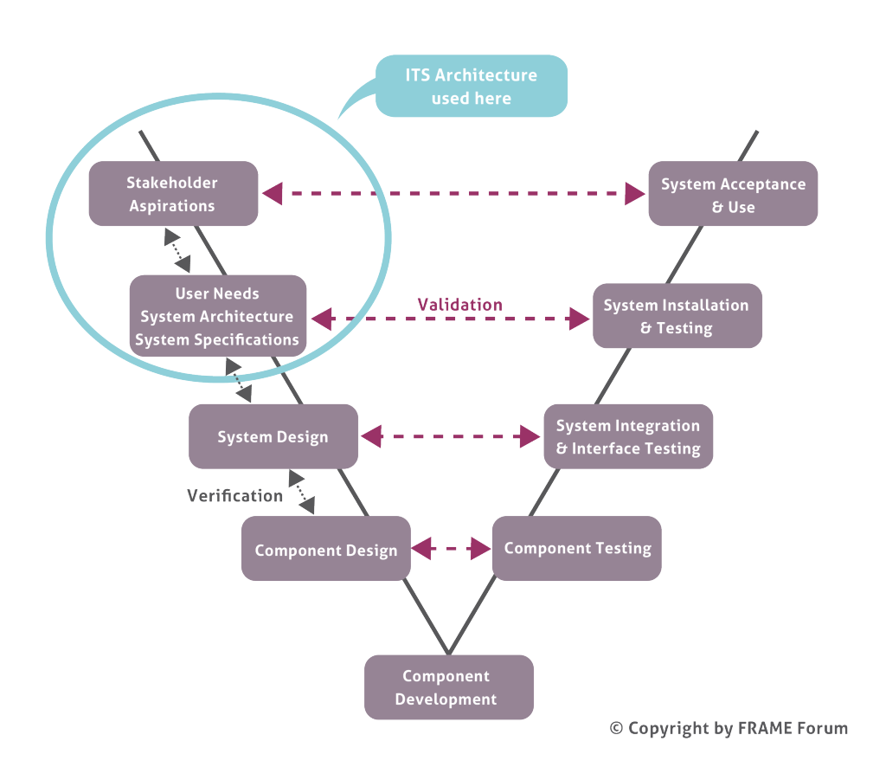](https://webcf.waybackmachine.org/web/20201230134908/https:/frame-online.eu/wp-content/uploads/2015/03/System-Engineering-V-Model-N.png)

The early part of a system lifecycle is sometimes glossed over quickly so that the “more exciting” stages of design and implementation, and the use of (often new) technology can be reached as quickly as possible. The danger of taking this approach is that the early products (Stakeholder Aspirations, User Needs, System Architecture and System Specifications) will not be complete and/or correct. Thus the resulting System Design, which will be verified against them, will also be incomplete and/or incorrect, and the development may be some way up the right hand side of the V-model lifecycle before the discrepancies begin to appear, making them much more expensive to rectify. This effect is illustrated below, and is sometimes called “The 10:100:1000 Rule” because the cost of correcting faults in a system increases exponentially (by about a factor of 10) during each successive stage of a lifecycle.

[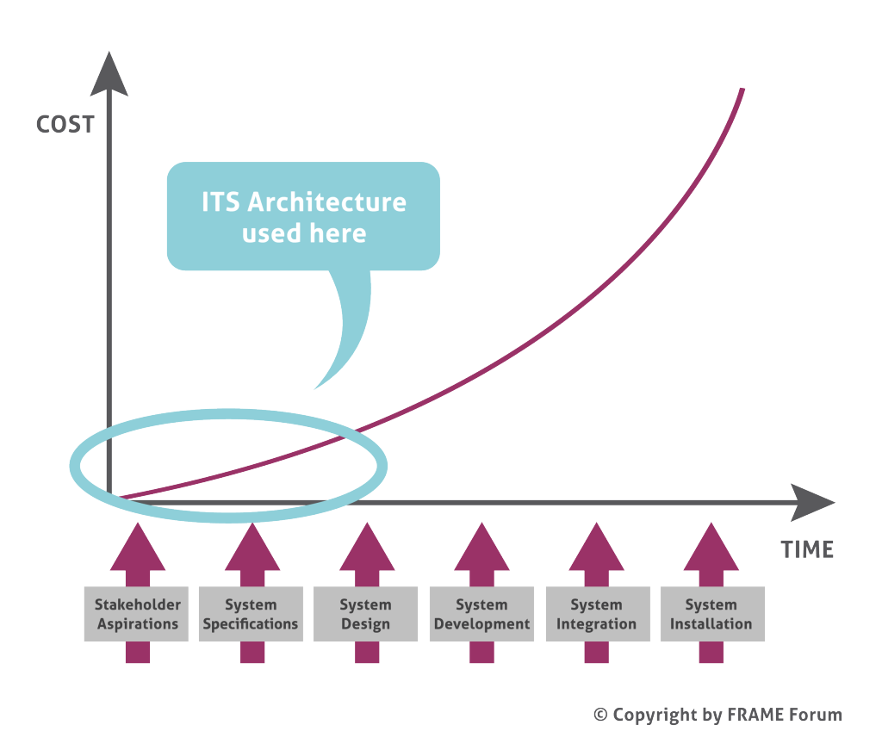](https://webcf.waybackmachine.org/web/20201230134908/https:/frame-online.eu/wp-content/uploads/2015/03/10-100-1000-Rule-N.png)

## Who is using the FRAME Architecture?

[Home](https://webcf.waybackmachine.org/web/20181114151706/http:/frame-online.eu/)  [FRAME ARCHITECTURE](https://webcf.waybackmachine.org/web/20181114151706/http:/frame-online.eu/frame-architecture)  [Detailed information](https://webcf.waybackmachine.org/web/20181114151706/http:/frame-online.eu/frame-architecture/detailed-information)  Who is using the FRAME Architecture?

*feel free to contact us:*  info(at)frame-online.net

The FRAME Architecture was originally created so that it could be used by any Member State, Region, City or Project within the European Union. At present there is no “legislation” that says it must be used, and so it is currently only used by those who wish to use it (see below). The FRAME Architecture is European only insofar as its contents are targeted towards the way things are done within the EU. Any other part of the world with similar requirements to those in the EU could also use the FRAME Architecture.

[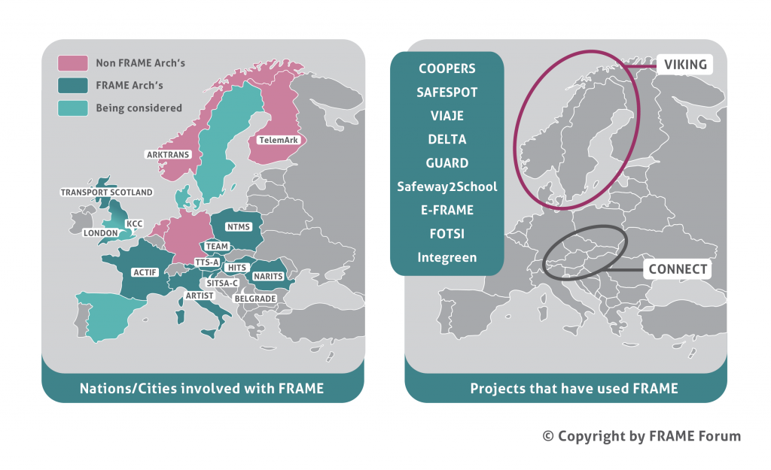](https://webcf.waybackmachine.org/web/20181114151706/http:/frame-online.eu/wp-content/uploads/2017/01/mapa-europe-new.png)

[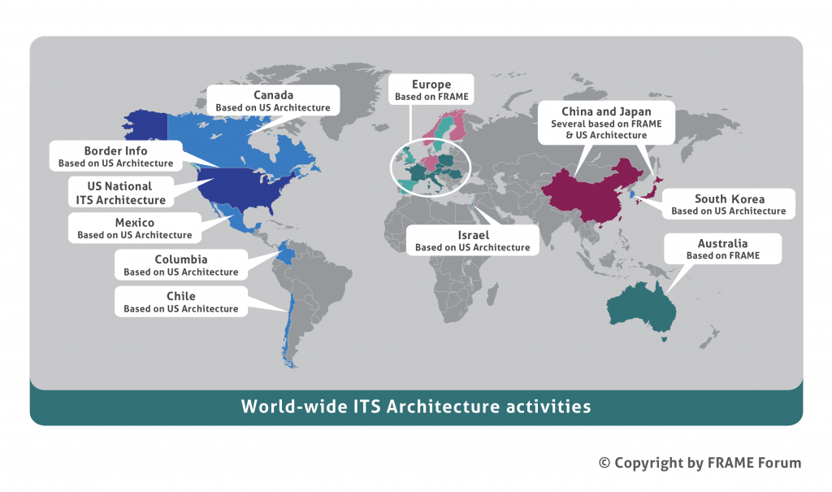](https://webcf.waybackmachine.org/web/20181114151706/http:/frame-online.eu/wp-content/uploads/2017/01/mapa-world-new.png)

## What are the FRAME User Needs?

[Home](https://webcf.waybackmachine.org/web/20201230134909/https:/frame-online.eu/)  [FRAME ARCHITECTURE](https://webcf.waybackmachine.org/web/20201230134909/https:/frame-online.eu/frame-architecture)  [Detailed information](https://webcf.waybackmachine.org/web/20201230134909/https:/frame-online.eu/frame-architecture/detailed-information)  What are the FRAME User Needs?

The FRAME User Needs have three principal uses, as follows.

* **Specification of the Functional View** – One or more User Needs provide the specification for what the functionality in the Functional View must do. Each Function is cross-referenced to one or more User Needs for which it helps to provide primary functionality.
* **Creating ITS Architecture Sub-sets** – see [Creating an ITS Architecture using FRAME](https://webcf.waybackmachine.org/web/20201230134909/https:/frame-online.eu/frame/detailed-information/creating-an-its-architecture-using-frame).
* **Describing ITS Applications and Services**– The User Needs provide a description of most ITS applications and services that might be required anywhere within the European Union. They can therefore be used for this descriptive purpose alone, e.g. by a research student wishing to know what ITS applications and services are being considered.

In order to satisfy these uses the User Needs need to be written in a manner that is clear and unambiguous, and at a level of abstraction that is sufficient to describe the primary functionality but without unnecessary detail. They should thus have the following properties:

* **“Shall language”**– In order to ensure that the User Needs specify what the functionality in the Functional View has to do, or features that must be included in the sub-systems and modules defined in the Physical View, they are written (in English) using the phraseology “The system shall…”. This ensures that each User Need is written from the systems’ point of view, and hence states the functionality required of that system, and not from the users’ point of view, which is likely to state how the results are to be used (and may be interpreted in more than one way).
* **Short**– User Needs are the entry points into the Functional View, and need to contain sufficient detail to identify the entry point precisely – only. When they are being written each phrase must have the answer “yes” to the question “is this necessary?”. A typical User Need comprises one English sentence three to five lines long (the original User Needs produced by KAREN were limited to 255 characters).
* **Technology Independence**– since the FRAME Architecture will have a lifespan longer than the technology that will be used to implement its features, the User Needs should state what the system is required to do, but not the mechanism for achieving it. Those User Needs that do not relate to functionality, e.g. Communications, Physical locations, should also follow this principle.
* **Unambiguous** – the meaning must be absolutely clear from the description. Thus, for example, whenever the word “information” is used it must be obvious from the context what should be contained within that information, otherwise it should be specified.
* **Testable** – since they form the basis of the FRAME Architecture and what is implemented from it, they must be written in a manner such that it is possible to check that each User Need is represented in some manner in the FRAME Architecture or the implementation.
* **Traceable and Unique**– since it must be possible to trace the manifestation of a User Need in a FRAME Architecture sub-set each User Need must have a unique identifier.
* **Singular** – If a User Need gives rise to a set of functionalities, it is assumed that all those functionalities will be required on every occasion the service is implemented. If this is not the case then it should be broken down into a number of separate User Needs.

On occasions these properties can be in conflict, in particular when writing User Needs which are unambiguous and singular, but also short, especially as there is a general desire not to have too many User Needs in the entire FRAME Architecture. Whilst no universal way has yet been found to resolve all such conflicts, some can be avoided by starting with a “high-level” User Need that describes a basic form of an application or service, followed by a number of optional extra User Needs that contain the detail of specific features.

Further Reading

A comprehensive explanation of the FRAME User Needs can be found [here](https://webcf.waybackmachine.org/web/20201230134909/https:/frame-online.eu/wp-content/uploads/2014/10/D13-Consolidated-UNs-for-Coop-Systems-Issue.pdf) (1MB pdf file).

The current set of User Needs can be found [here](https://webcf.waybackmachine.org/web/20201230134909/https:/frame-online.eu/wp-content/uploads/2014/10/FRAME-User-Needs-V4.1-01.pdf) (720kB pdf file).

## Why has UML not been used?

[Home](https://webcf.waybackmachine.org/web/20201230134909/https:/frame-online.eu/)  [FRAME ARCHITECTURE](https://webcf.waybackmachine.org/web/20201230134909/https:/frame-online.eu/frame-architecture)  [Detailed information](https://webcf.waybackmachine.org/web/20201230134909/https:/frame-online.eu/frame-architecture/detailed-information)  Why has UML not been used?

1. UML, or the Universal Modelling Language, describes notations that should be used for many different types of model, including Data Flow Models which are used by FRAME. Thus UML has been used!
2. **Suitability** – UML is usually associated with Object Oriented (OO) modelling, which is particularly suitable for describing systems that are Data driven (rather than Function driven). The level of abstraction used by FRAME tends to be Function driven.
3. **Comprehension** – “Object models developed during requirements analysis certainly simplify the transition to object-oriented design and programming. However, I have found that end-users of a system often find object models unnatural and difficult to understand. They often prefer to adopt a more functional, data-processing view.” [1]. Indeed, although ITS Architectures have been developed using OO techniques, they have not been understood by others, and thus not used.
4. **Framework**– The FRAME Architecture is a Framework Architecture from which self-consistent sub-sets can be extracted. It is not clear how this could be done easily, and in general, using OO techniques.
5. **Level of Abstraction**– the output from a FRAME Architecture sub-set is often a high-level System Description as part of a Call for Tender (see [Planning Integrated Deployments](https://webcf.waybackmachine.org/web/20201230134909/https:/frame-online.eu/frame/detailed-information/planning-integrated-its-deployments)). This will then be used by the company that is to supply the system, which could use UML in its development process.

The methodology used by the FRAME Architecture is based on that proposed by Hatley and Pirbhai[2] and uses Data Flow Diagrams to define the Functional View. Although, for ease of their management the Data Flow Diagrams are described in an hierarchical manner, the FRAME Architecture, and thus the Data Base used by the Selection Tool, is *defined* at the lowest level.

[1] Sommerville I, “Software Engineering” (6th Ed), Addison Wesley, 2001. ISBN 0-201-39815-X

[2] Hatley D J and Pirbhai I A, “Strategies for Real-Time Systems Specification”, Dorset House, 1987, ISBN 0-932633-11-0

## How can you use the Organisational View?

[Home](https://webcf.waybackmachine.org/web/20201230134910/https:/frame-online.eu/)  [FRAME ARCHITECTURE](https://webcf.waybackmachine.org/web/20201230134910/https:/frame-online.eu/frame-architecture)  [Detailed information](https://webcf.waybackmachine.org/web/20201230134910/https:/frame-online.eu/frame-architecture/detailed-information)  How can you use the Organisational View?

The Organisational View is usually a derivative of the Physical View. It is used to show the organisations that will own, and/or operate, and/or maintain the Sub-systems and Modules in the Physical View. This is very useful for highlighting the relationships between different organisations and any conflicts that may arise. It can also be used to look at how data will have to be, or could be, shared between organisations.

An Organisational View usually considers the following specific issues:

* Each service that can be provided by the functionality in an ITS architecture will be used by somebody or an organisation.
* Each sub-system and module within the Physical View must be owned and/or managed by an organisation.
* The relationship between organisations can take one of the following forms:
  + **Directional** – one (or part of an) organisation has the power to direct, or manage, what another (or other part of an) organisation does and, possibly how it is done, e.g. the organisation managing the road network manages how public transport uses the road network.
  + **Long Term Contractual** – one organisation is required to perform a defined service for, or on behalf of, another organisation, e.g. a communications provider will provide a service that enables data or information to be communicated from one part of the system to another;
  + **Short Term Contractual**– one organisation, or individual, pays another organisation for a well-defined service, e.g. the Traveller pays to use Public Transport

Some sub-systems and modules will provide data for others and this can raise organisational issues if the data that is provided is incorrect and/or incomplete. When such a failure occurs, it is important to be able to identify who is responsible for its occurrence, for rectifying it and for preventing it happening again. This may not be obvious if the failure is in an emergent property of a service provided by sub-systems owned by more than one organisation, each supplying part of the total service (see below).

[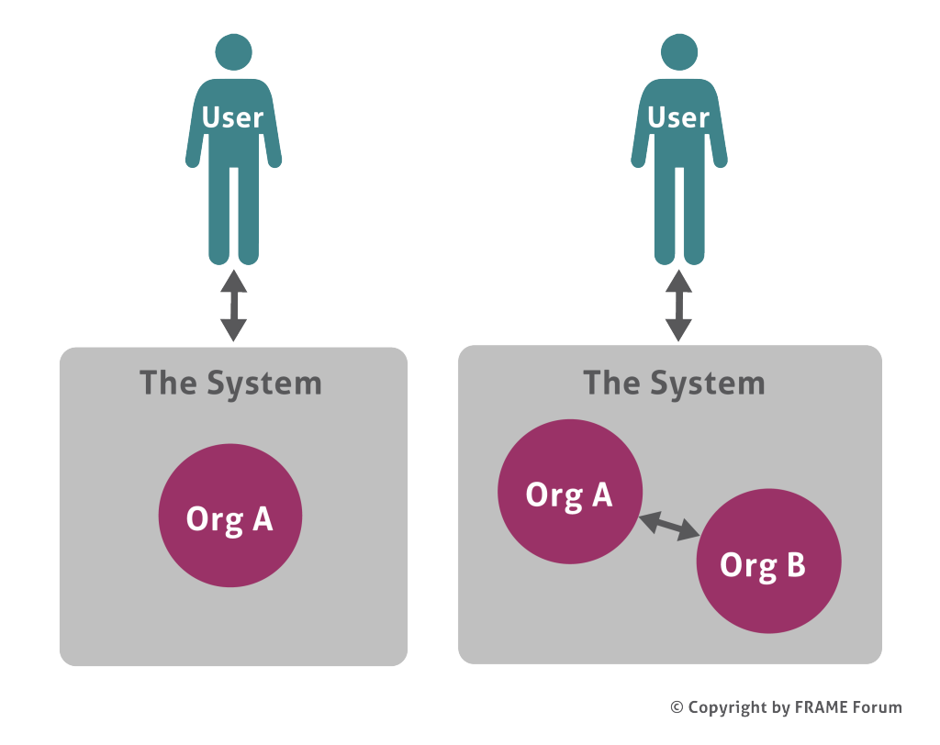](https://webcf.waybackmachine.org/web/20201230134910/https:/frame-online.eu/wp-content/uploads/2015/03/Who-owns-the-System-N.png)

On occasions there is a need, or a wish, to impose a particular type of model on the Organisational View. In this situation see [How can you plan the Behaviour of an integrated ITS?](https://webcf.waybackmachine.org/web/20201230134910/https:/frame-online.eu/frame-architecture/detailed-information/ag.pne.moonhost.pl/frame/detailed-information/how-can-you-plan-the-behaviour-of-an-integrated-its)

## How can you plan the Behaviour of an integrated ITS?

[Home](https://webcf.waybackmachine.org/web/20201230134911/https:/frame-online.eu/)  [FRAME ARCHITECTURE](https://webcf.waybackmachine.org/web/20201230134911/https:/frame-online.eu/frame-architecture)  [Detailed information](https://webcf.waybackmachine.org/web/20201230134911/https:/frame-online.eu/frame-architecture/detailed-information)  How can you plan the Behaviour of an integrated ITS?

There are occasions when it is necessary to impose a particular form of behaviour, or a particular organisation structure, on integrated ITS. Examples include the need to:

* Localise safety functions so that they will continue to work when “higher” (non-safety) functions are absent;
* Provide a command and control structure that conforms to certain legal, or constitutional, requirements.

In these circumstances an *overall concept*has to be specified to which the *system structure*must conform (see below).

[](https://webcf.waybackmachine.org/web/20201230134911/https:/frame-online.eu/wp-content/uploads/2015/03/Architecture-Layers-n.png)

Further Reading

[The FRAME Architecture and the ITS Action Plan](https://webcf.waybackmachine.org/web/20201230134911/https:/frame-online.eu/frame/detailed-information/relationship-with-the-its-action-plan-and-its-directive)

## How can you deal with Liabilty Issues?

[Home](https://webcf.waybackmachine.org/web/20201230134911/https:/frame-online.eu/)  [FRAME ARCHITECTURE](https://webcf.waybackmachine.org/web/20201230134911/https:/frame-online.eu/frame-architecture)  [Detailed information](https://webcf.waybackmachine.org/web/20201230134911/https:/frame-online.eu/frame-architecture/detailed-information)  How can you deal with Liabilty Issues?

Integrated ITS may be provided by components owned by more than one organisation, and some hazards may be the result of interactions between those components. It will therefore be necessary to identify who is responsible for dealing with the consequences, both legal and technical. An ITS Architecture provides a model of the components, and their interconnections, and thus a basis for analysing these issues.

Safety

All ITS applications and services should be considered as being safety-related, until they have been shown not to be, using a process called Preliminary Safety Analysis. The safe use of ITS has three principal components:

* **(Functional) System Safety**– e.g. relating to design faults or system malfunctions. This is provided by including additional stages in the system development lifecycle during which the probability of a dangerous failure is reduced to an acceptable level.
* **Human-Machine Interactio**n (HMI) – relating to usability, e.g. perception, overload, underload. A key question is how much information can be presented to a driver before it stops being a help and starts to be a distraction from the main driving task.
* **Traffic Safety**– all components of the traffic system working together. This relates to the direct or indirect effects of the ITS on the safety of the traffic situation.

An ITS Architecture provides a model for a safety analysis, and advice on how to approach safety issues can be found in the UTMC22 report in [Other Related Reports](https://webcf.waybackmachine.org/web/20201230134911/https:/frame-online.eu/library/other-related-reports).

Security

Security abuse commonly includes, but is not limited to, unauthorised disclosure of information (loss of confidentiality), unauthorised modification of data (loss of integrity), and unauthorised deprivation of access to the asset (loss of availability). Users and owners of ITS must have confidence that there are countermeasures that will minimise any security risk. Whilst security is necessary for privacy, it is not sufficient.

A study of an ITS Architecture will identify where security issues need to be considered. It should also be noted that ETSI TC ITS WG5 is addressing the need for security in ITS communications.

Privacy

Through their frequent use of vehicle identities, Cooperative Systems need to include the requirements for privacy right from the start of the initial designs. Care will have to be taken to ensure that the requirements of the European Privacy Directive are considered at every stage of the design process. A particular issue is that just making the identity of a vehicle “anonymous” is not always sufficient to ensure privacy in all situations.

A study of an ITS Architecture will identify where privacy issues need to be considered, in conjunction with CEN standard TR16742.

Further Reading

See [Other Related Reports](https://webcf.waybackmachine.org/web/20201230134911/https:/frame-online.eu/library/other-related-reports)

## How can you undertake a Risk Analysis?

[Home](https://webcf.waybackmachine.org/web/20201126092453/https:/frame-online.eu/)  [FRAME ARCHITECTURE](https://webcf.waybackmachine.org/web/20201126092453/https:/frame-online.eu/frame-architecture)  [Detailed information](https://webcf.waybackmachine.org/web/20201126092453/https:/frame-online.eu/frame-architecture/detailed-information)  How can you undertake a Risk Analysis?

A risk analysis assesses the hazards that may affect an ITS deployment. Those hazards with the most severe risks should be provided with a mitigation strategy, and each strategy should be assigned to an Owner who is responsible for its implementation.

Risk Analysis is divided into five steps:

* Identify the ***hazard*** (what might go wrong), be it a financial, technical, organisational, institutional or a requirement hazard;
* Identify the consequence(s) of each hazard, there may be more than one, and assign a ***probability*** that they will occur, e.g. Low, Medium, High [1];
* Assign an ***impact*** to each consequence, e.g. Low, Medium, High [1];
* Categorise the ***risk*** (probability vs. impact) of each consequence, e.g. using a risk graph (see below)

[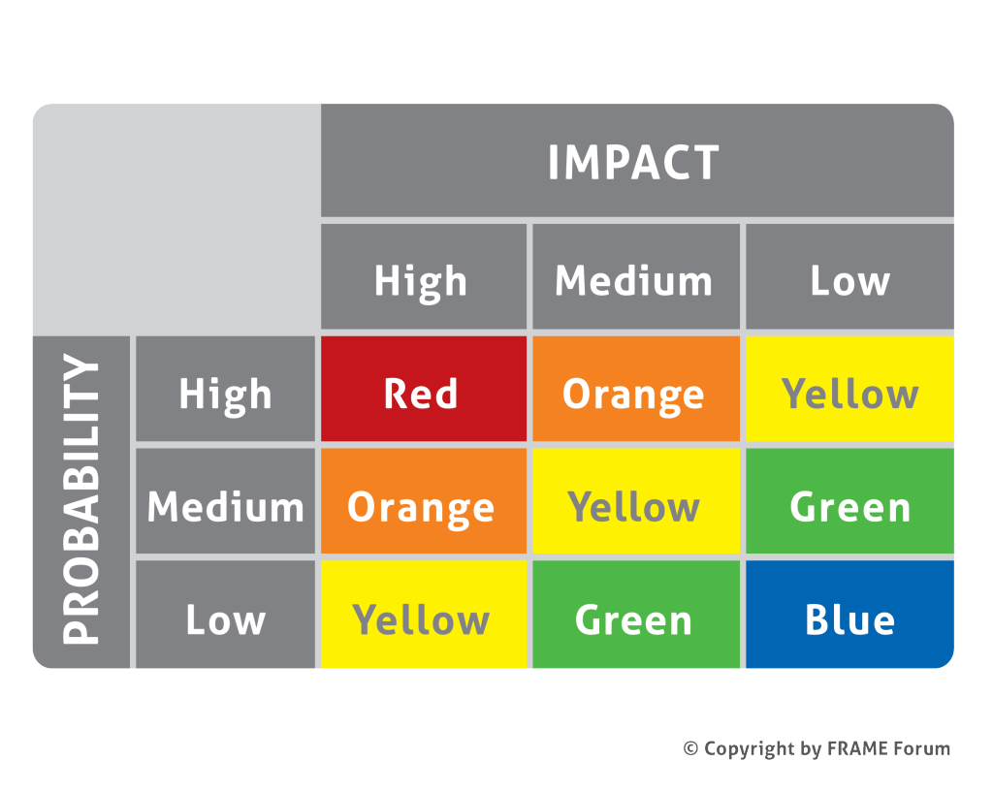](https://webcf.waybackmachine.org/web/20201126092453/https:/frame-online.eu/wp-content/uploads/2015/03/Example-Risk-Graph-N.png)Example Risk Graph [1]

* Decide which categories of risk need a mitigation strategy, e.g. all red and orange, and identify the actions that need to be taken to reduce the risk to an acceptable level [1].

The result should be a list of Hazards, with their Mitigation Strategies and Owners

[1] The examples given above are only examples. The number of possible Probabilities and Impacts, as well as the content of the Risk Graph must be approved by a suitable authority. In the case of Safety and Security hazards they may have legal consequences.

Further Reading

See [The RAID Study](https://webcf.waybackmachine.org/web/20201126092453/https:/frame-online.eu/wp-content/uploads/2014/10/raid-risk-analysis.zip)

## How can you undertake a Cost/Benefit Analysis?

[Home](https://webcf.waybackmachine.org/web/20201126091343/https:/frame-online.eu/)  [FRAME ARCHITECTURE](https://webcf.waybackmachine.org/web/20201126091343/https:/frame-online.eu/frame-architecture)  [Detailed information](https://webcf.waybackmachine.org/web/20201126091343/https:/frame-online.eu/frame-architecture/detailed-information)  How can you undertake a Cost/Benefit Analysis?

[Cost–benefit analysis](https://webcf.waybackmachine.org/web/20201126091343/http:/en.wikipedia.org/wiki/Cost%E2%80%93benefit_analysis) is a systematic process for calculating and comparing benefits and costs of a project. The costs of an ITS project can be divided between the Capital Costs, e.g. for the acquisition and deployment of equipment, and the Revenue Costs, e.g. for staff. The benefits often cannot be quantified in monetary terms, but may include reduced delays, improved environment, etc.

The following are some of the resources that are freely available:

* [http://www.ibec-its.co.uk](https://webcf.waybackmachine.org/web/20201126091343/http:/www.ibec-its.co.uk/) (European and US figures organisation that concentrates on “evaluation”)
* [http://www.itstoolkit.co.uk](https://webcf.waybackmachine.org/web/20201126091343/http:/www.itstoolkit.co.uk/casestudies.htm) (results from UK based ITS deployments)
* [http://www.2decide.eu](https://webcf.waybackmachine.org/web/20201126091343/http:/www.2decide.eu/) (FP7 project)
* [http://www.benefitcost.its.dot.gov/its/benecost.nsf/CostHome](https://webcf.waybackmachine.org/web/20201126091343/http:/www.benefitcost.its.dot.gov/its/benecost.nsf/CostHome) (US based costs figures)
* [http://www.benefitcost.its.dot.gov/its/benecost.nsf/BenefitsHome](https://webcf.waybackmachine.org/web/20201126091343/http:/www.benefitcost.its.dot.gov/its/benecost.nsf/BenefitsHome) (US based benefits figures)

# Library

## Other Related Reports

[Home](https://webcf.waybackmachine.org/web/20201230134447/https:/frame-online.eu/)  [LIBRARY](https://webcf.waybackmachine.org/web/20201230134447/https:/frame-online.eu/library)  Other Related Reports

**These reports contain information that relates to ITS engineering in general, but not explcitly ITS Architecture.**

**UTMC22 – Framework for the Development and Assessment of Safety-Related (Inter-)Urban Traffic Management Systems (March 2000)**

This Framework describes a process to analysis the safety hazards associated with an ITS and to assess their risk; to identify safety requirements that will reduce the risk to an acceptable level; and to demonstrate that the safety requirements have been applied correctly. It brings together the topics of Functional System Safety, Traffic Safety and Human Machine Interaction. The Framework draws heavily on the results of earlier EC funded projects undertaken in the FP2 DRIVE I, FP3 DRIVE II and FP4 EC research programmes, in particular CODE, DRIVE Safely, EMCATT, HINT, HOPES and PASSPORT, and the UK SafeIT project [MISRA](https://webcf.waybackmachine.org/web/20201230134447/http:/www.misra.org.uk/).

The project that created this Framework was funded by the UK Department for Transport as part of the UTMC programme.

[Download](https://webcf.waybackmachine.org/web/20201230134447/https:/frame-online.eu/wp-content/uploads/2014/10/utmc22-framework.pdf) (690kB pdf file)

**PASSPORT – Framework for Preliminary Safety Analysis (December 1995)**

This Framework describes a systematic methodology for performing a safety analysis on the initial concept of an Intelligent Transport System, to identify the safety hazards that might be associated with that concept and their risk (effect x probability), and hence formulate the initial Safety Requirements that will bring each risk to be “as low as reasonably practicable” (ALARP).

The project  that created this Framework was funded by the  European Commission.

[Download](https://webcf.waybackmachine.org/web/20201230134447/https:/frame-online.eu/wp-content/uploads/2020/09/PASSPORT-Preliminary-Safety-Analysis.pdf) (4MB pdf file)